

**School of Engineering and Technology**

**Artificial Intelligence/Machine Learning**

*(Practical File)*

**18BCS-0AI32L**

***Submitted To:***

***Submitted By:***

Name: Akshay Kumar

Roll Number: 170BTCCSE032

Branch: Computer Science and Engg.

Year/Sem: 3rd Year – 5th Semester

Faculty: Ujjawal

**INDEX**

|  |  |  |  |
| --- | --- | --- | --- |
| **S.No** | **Program Title** | **Date** | **Signature** |
| **1** |  |  |  |
| **2** |  |  |  |
| **3** |  |  |  |
| **4** |  |  |  |
| **5** |  |  |  |
| **6** |  |  |  |
| **7** |  |  |  |
| **8** |  |  |  |
| **9** |  |  |  |
| **10** |  |  |  |
| **11** |  |  |  |
| **12** |  |  |  |
| **13** |  |  |  |
| **14** |  |  |  |
| **15** |  |  |  |

Program 1: Introduction to python and programming.

1.Variables and Strings

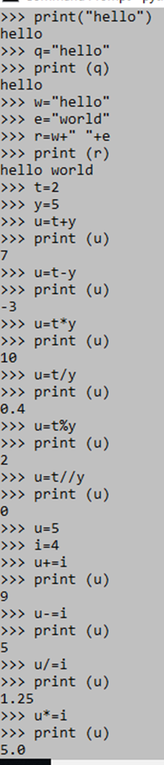

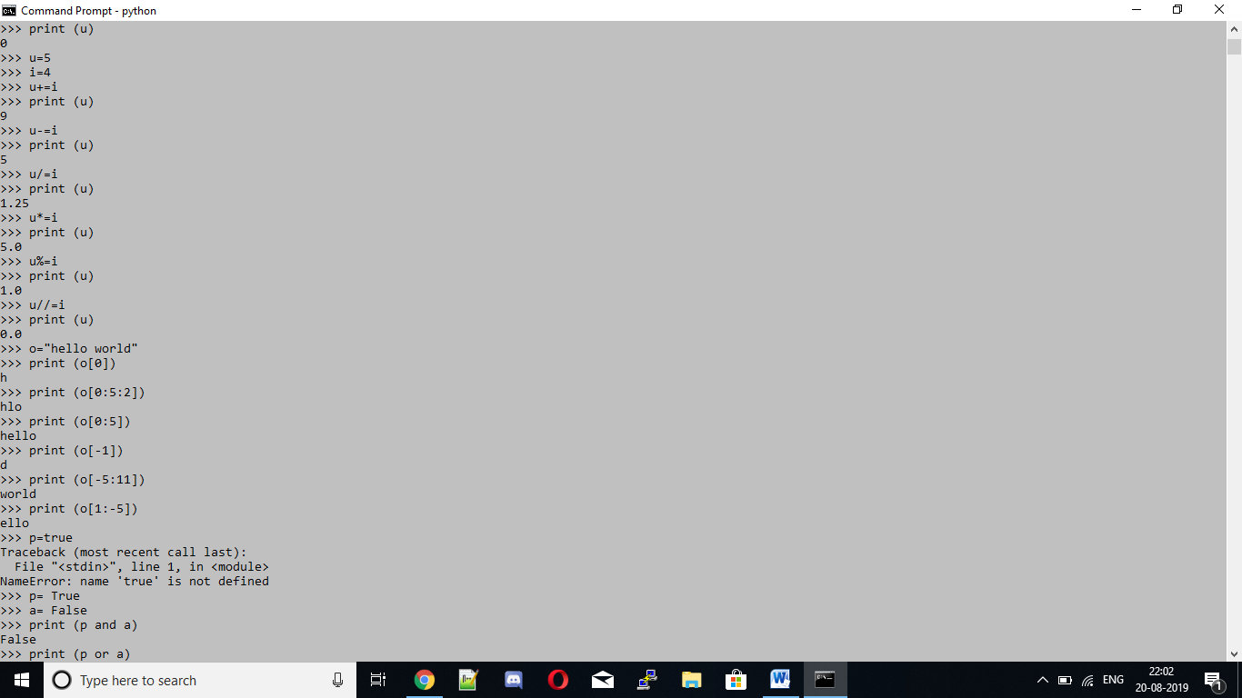

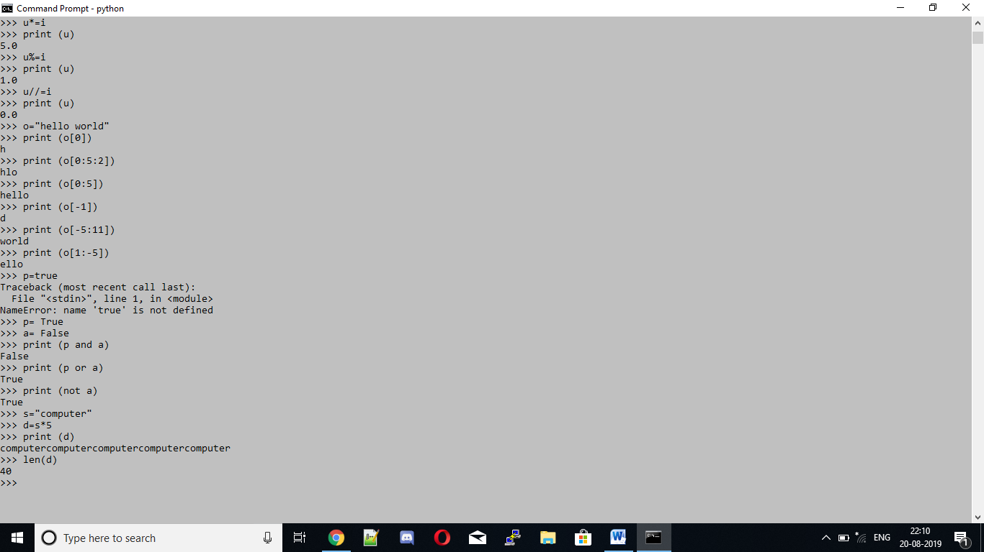

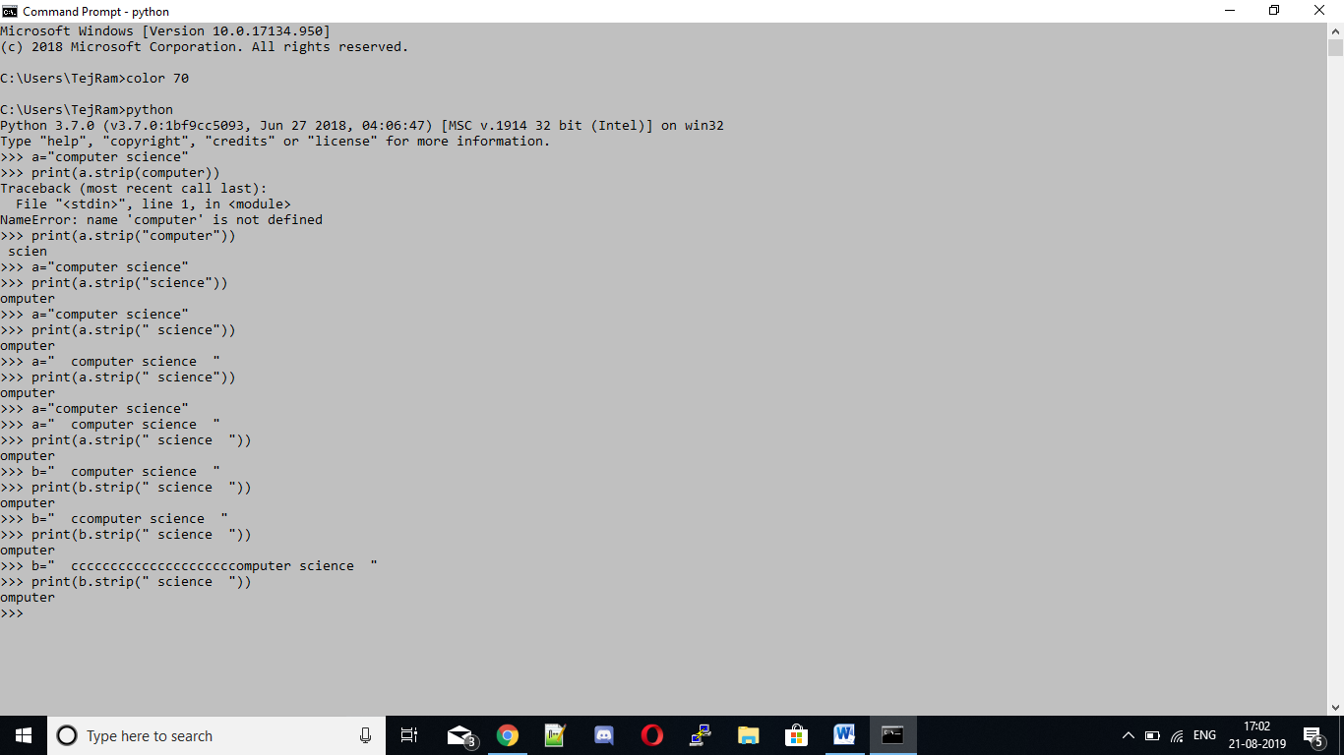

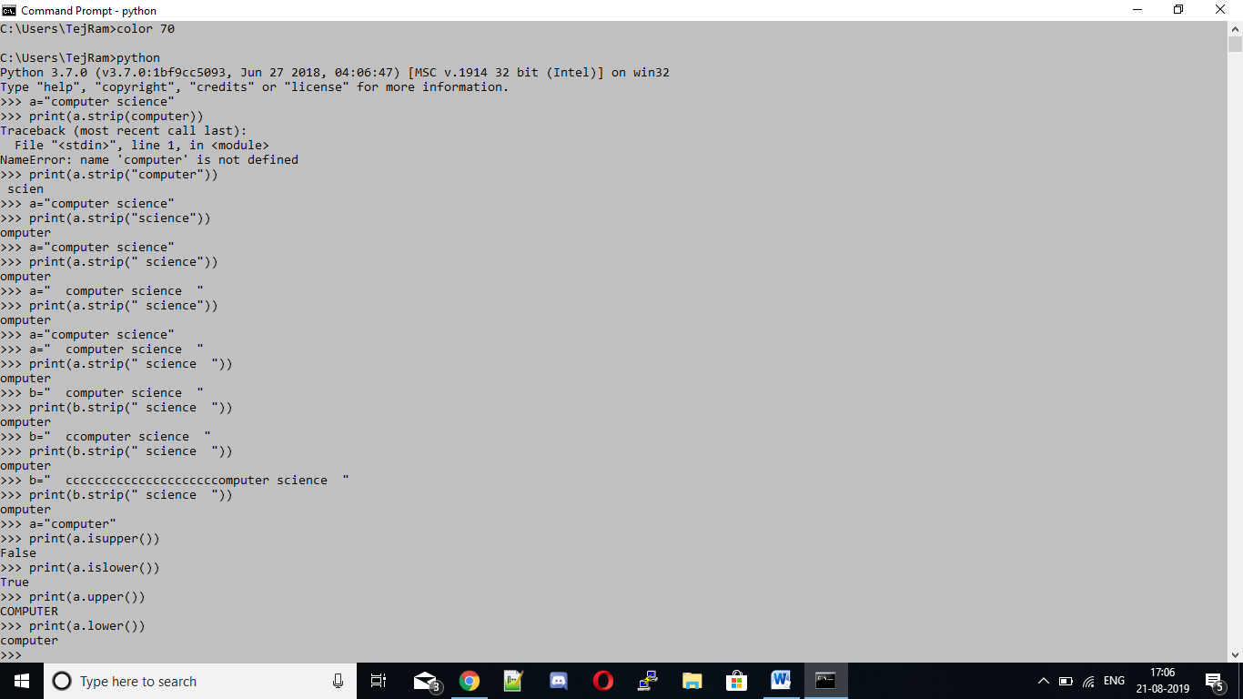

Arithmetic operators: Arithmetic operators are used to perform mathematical operations like addition, subtraction, multiplication and division.

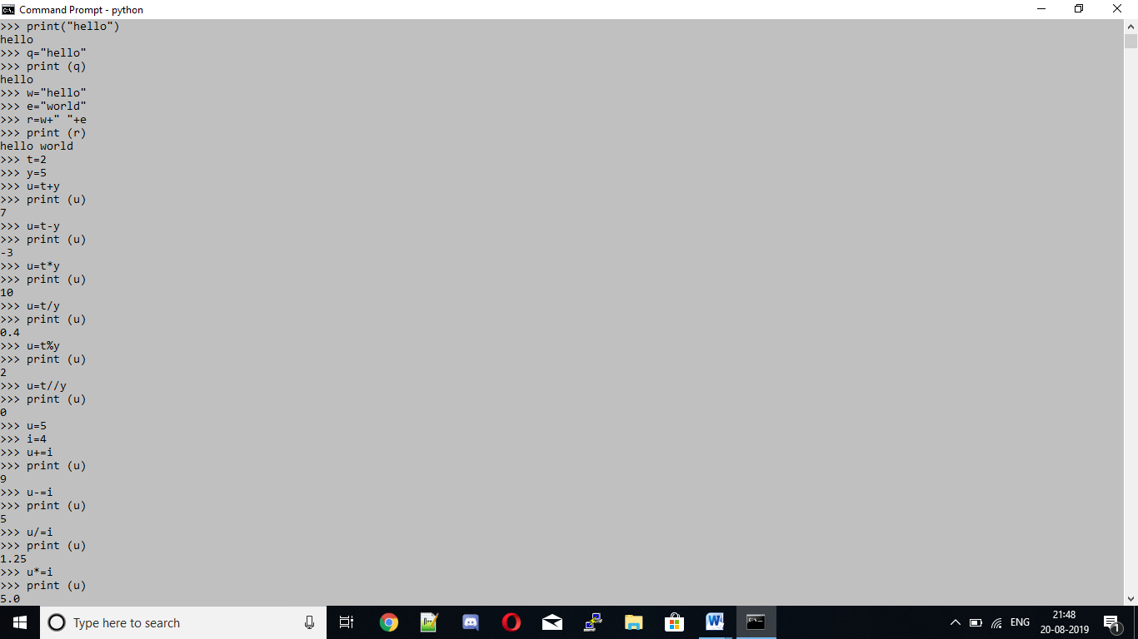

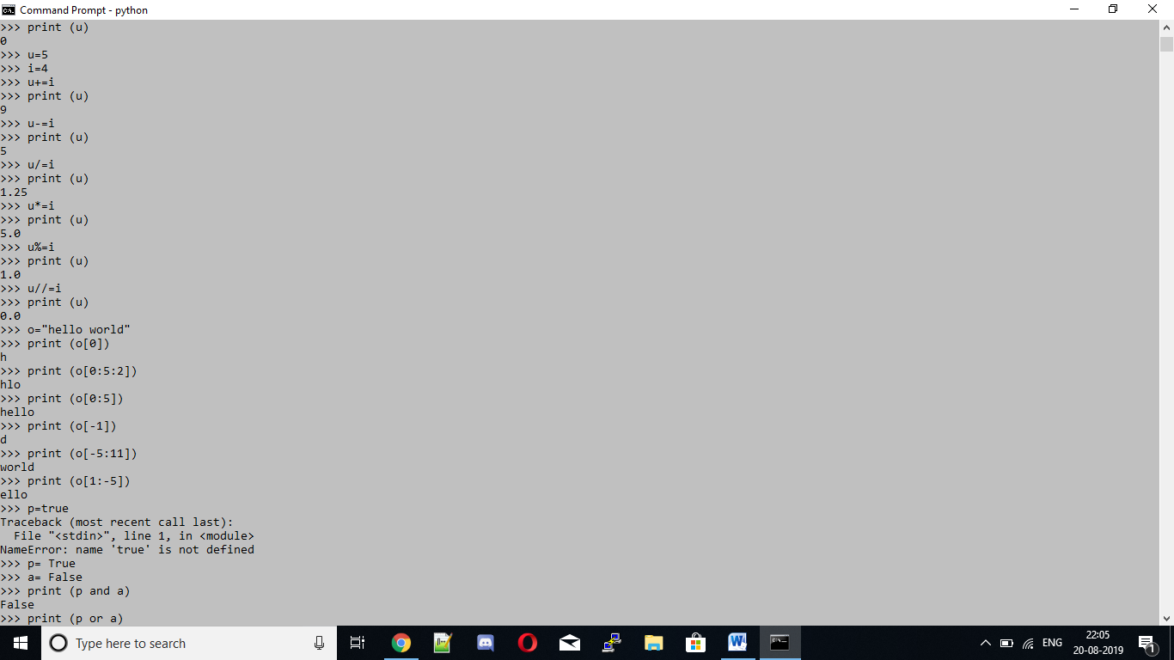

Logical operators: Logical operators perform Logical AND, Logical OR and Logical NOT operations.

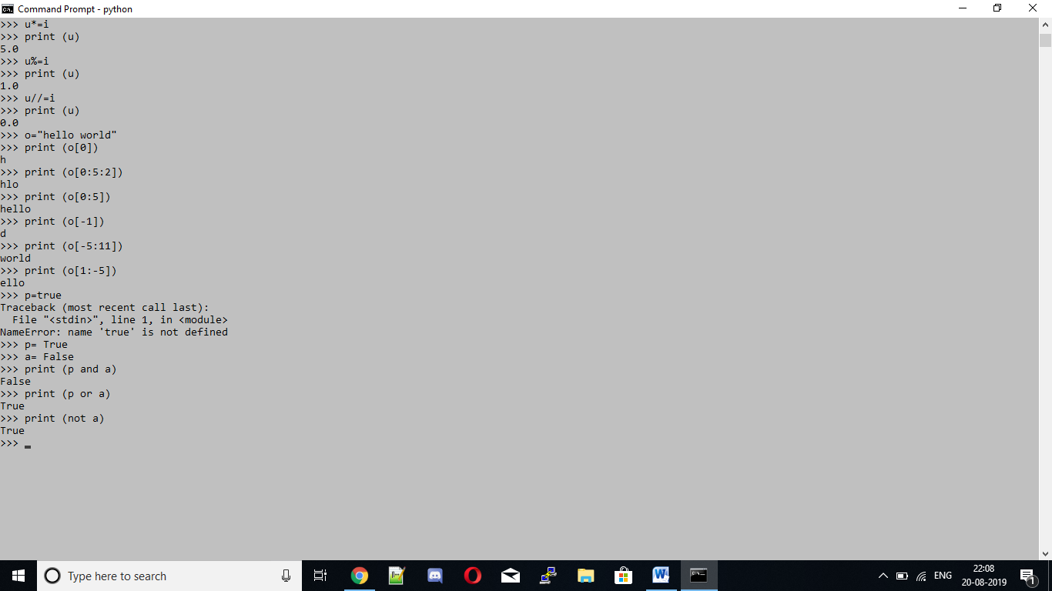

2. Lists

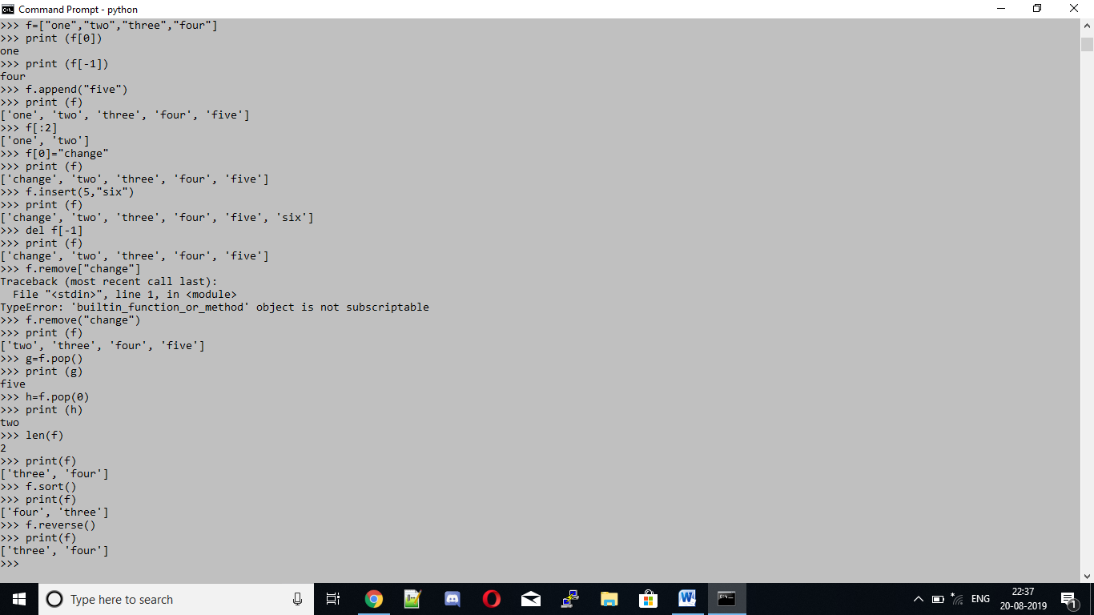

3. Tuples

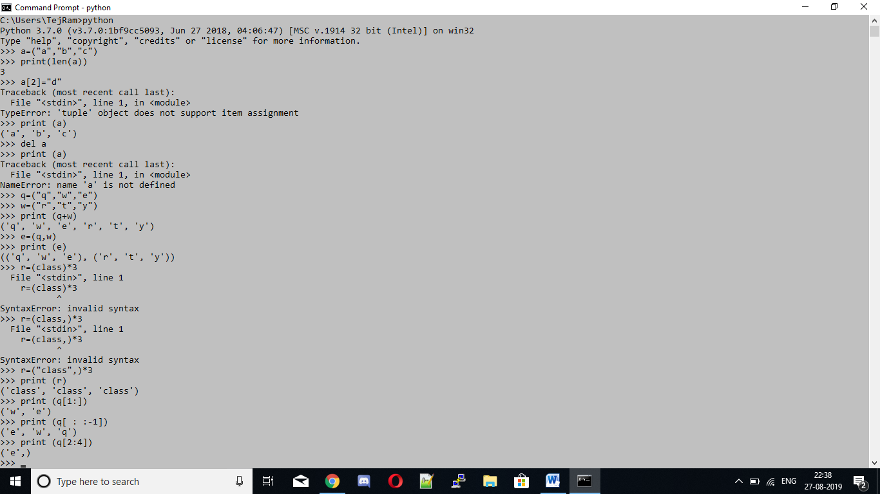

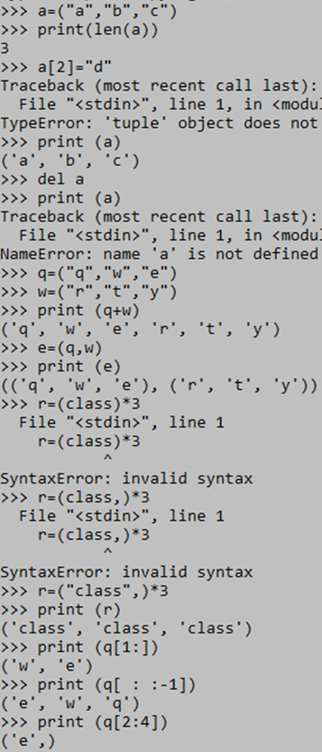

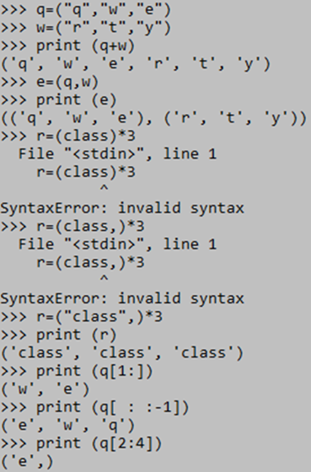

Sets:

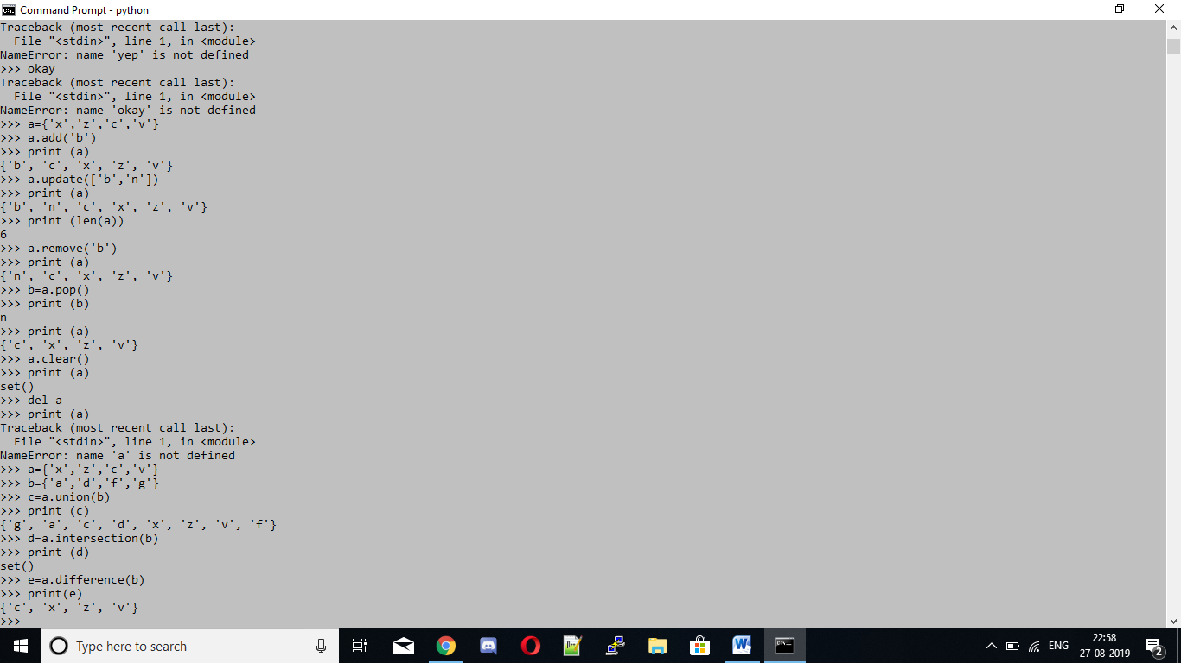

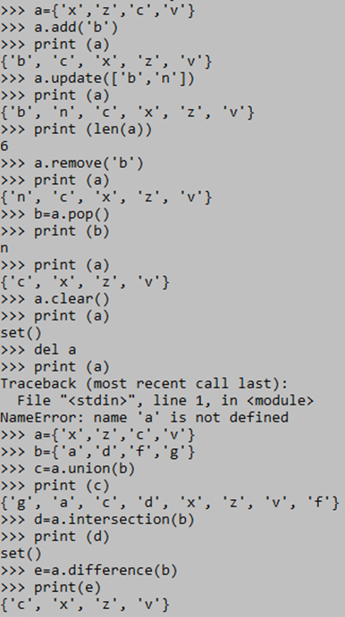

4. Dictionaries

